Реляционные и булевые операторы:
Реляционные:
- Назначение: Узнать какие модели есть у выбранного бренда
- SQL-query: SELECT name from models WHERE company_id = (SELECT id from companies where name='Volkswagen')
- Результат: -
Булевые:
- Назначение: Все компание у которых офис и фабрика находится в одном месте или количество работников больше 16000
- SELECT name FROM companies WHERE office = factory OR count_of_workers > 16000

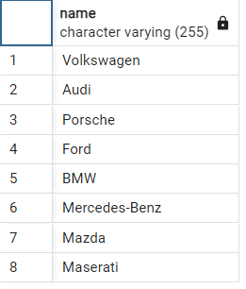
in, between, like:
in:
- -
- SELECT name FROM companies WHERE office IN ('Wolfsburg', 'Las Vegas')
- -
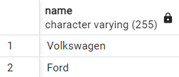
between:
- -
- SELECT name FROM body_type WHERE id BETWEEN 4 AND 8
- -
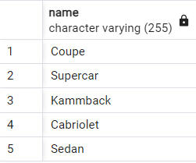
like:
- -
- SELECT name, office FROM companies WHERE office LIKE 'S%' or office LIKE 'M%'
- -
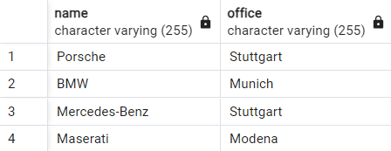
групповые функции:
sum:
- -
- SELECT SUM(count_of_workers) FROM companies WHERE office LIKE 'S%'
- -
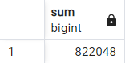
count:
- -
- SELECT COUNT(*) FROM companies WHERE office LIKE 'S%' or office LIKE 'M%'
- -
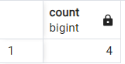
avg:
- -
- SELECT AVG(count_of_workers) FROM companies WHERE office LIKE 'S%' or office LIKE 'M%'
- -
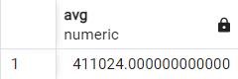
min:
- -
- SELECT MIN(count_of_workers) FROM companies WHERE office LIKE 'S%' or office LIKE 'M%'
- -
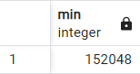
max:
- -
- SELECT MAX(count_of_workers) FROM companies WHERE office LIKE 'S%' or office LIKE 'M%'
- -
